Suggested solution of assignment 1

Chapter 1

- Below we list several variables. Which of these variables are quantitative and which are qualitative? Explain.
a. The dollar amount on an accounts receivable invoice.
b. The net profit for a company in 2005.
c. The stock exchange on which a company’s stock is traded.
d. The national debt of the United States in 2005.
e. The advertising medium (radio, television, or print) used to promote a product.

Solution:
a. Quantitative; dollar amounts correspond to values on the real number line.
b. Quantitative; net profit is a dollar amount.
c. Qualitative; which stock exchange is a category.
d. Quantitative; national debt is a dollar amount.
e. Qualitative; media is categorized into radio, television, or print.

2. Classify each of the following qualitative variables as ordinal or nominative. Explain your answers.
Qualitative Variables Categories
Statistics course letter grade A B C D F
Door choice on Let’s Make A De al Door﹟1 Door﹟2
Personal computer ownership Yes No
Restaurant rating ***** **** *** ** *
Incoming tax filing status Married filing jointly; Married filing separately; Single; Head of household; Qualifying widow(er)
Solution: Ordinal, nominative, nominative, ordinal and nominative.
Note：Ordinal: There is a meaningful ordering of the categories.
Nominative: There is no meaningful ordering of the categories.

Chapter 2

3. Forbes magazine publishes the Forbes Platinum 400 –a list of the “Best Big Companies in America” as selected by the magazine’s writers and editors. Table above gives the best companies in the retailing industry as given in this list on the Forbes website on March 16, 2005. (Data in the last page).
a. Construct a stem-and-leaf display of the profit margin percentages for the best performing retailers as given in Table. Find the median and then describe the distribution of profit margins.
b. Construct a stem-and leaf display of the return on capital percentages for the retailers in Table. Find the median and then describe the distribution of the return.
c. Compare the distributions of the profit margins and return on capital percentages.
d. Organize data of the profit margin percentages into a frequency distribution.
e. Construct a histogram of the profit margin percentages.
Solution:
a. Stem-and-Leaf Display of Profit Margin n = 35
Leaf Unit = 0.10
 | Frequency |  | Stem
 | 2 |  | 1| | 1 8
 | 2 |  | 2| | 2 9
 | 6 |  | 3| | 1 2 3 6 6 9
 | 4 |  | 4| | 0 4 7 9
 | 12 |  | 5| | 0 0 0 2 3 4 8 9 9 9 9 9
 | 3 |  | 6| | 1 8 9
 | 1 |  | 7| | 0
 | 1 |  | 8| | 6
 | 1 |  | 9| | 2
 | 1 |  | 10| | 9
 | 1 |  | 11| | 2
 |  |  | 12|
 |  |  | 13|
 |  |  | 14|
 |  |  | 15|
 |  |  | 16|
 |  |  | 17|
 |  |  | 18|
 |  |  | 19|
 |  |  | 20|
 |  |  | 21|
 |  |  | 22|
 |  |  | 23|
 | 1 |  | 24| | 0

The median is 5.2. Distribution is skewed to the right.

b. Stem-and-Leaf of Display on Capital n = 35
Leaf Unit = 0.10
 | Frequency |  | Stem
 | 1 |  | 0| | 0
 |  |  | 1|
 |  |  | 2|
 |  |  | 3|
 | 1 |  | 4| | 0
 |  |  | 5|
 |  |  | 6|
 |  |  | 7|
 | 2 |  | 8| | 3 6
 | 1 |  | 9| | 2
 |  |  | 10|
 | 4 |  | 11| | 0 2 5 6
 | 3 |  | 12| | 6 7 8
 | 1 |  | 13| | 1
 | 3 |  | 14| | 4 7 7
 | 3 |  | 15| | 2 4 9
 | 1 |  | 16| | 5
 | 2 |  | 17| | 0 6
 | 1 |  | 18| | 3
 | 3 |  | 19| | 2 7 8
 | 3 |  | 20| | 3 6 8
 | 2 |  | 21| | 1 7
 | 1 |  | 22| | 8
 |  |  | 23|
 |  |  | 24|
 | 2 |  | 25| | 1 7
 |  |  | 26|
 |  |  | 27|
 |  |  | 28|
 |  |  | 29|
 |  |  | 30|
 |  |  | 31|
 |  |  | 32|
 | 1 |  | 33| | 4

The median is 15.4. Distribution is quite variable, but symmetric with both high and low outliers.

c. Profit margins are skewed to the right and less spread out when compared to Return on Capital.
d. k=6
Class length=(24-1.1)/6=3.81 round up to 3.9
To form the first class, start with the smallest value 1.1.
Up limit of the first chass is 1.1+3.9-0.1=4.9
Class Frequency Boundaries
1.1 to 4.9 14 1.05, 4.95
5.0 to 8.8 17 4.95, 8.85
8.9 to 12.7 3 8.85, 12.75
12.8 to 16.6 0 12.75, 16.65
16.7 to 20.5 0 16.65, 20.55
20.6 to 24.4 1 20.55, 24.45

 |  | Profit |  |  |  |  |  | cumulative
 | lower |  | upper | midpoint | width | frequency | percent | frequency | percent
 | 1.05 | < | 4.95 | 3.00 | 3.90 | 14 | 40.0 | 14 | 40.0
 | 4.95 | < | 8.85 | 6.90 | 3.90 | 17 | 48.6 | 31 | 88.6
 | 8.85 | < | 12.75 | 10.80 | 3.90 | 3 | 8.6 | 34 | 97.1
 | 12.75 | < | 16.65 | 14.70 | 3.90 | 0 | 0.0 | 34 | 97.1
 | 16.65 | < | 20.55 | 18.60 | 3.90 | 0 | 0.0 | 34 | 97.1
 | 20.55 | < | 24.45 | 22.50 | 3.90 | 1 | 2.9 | 35 | 100.0
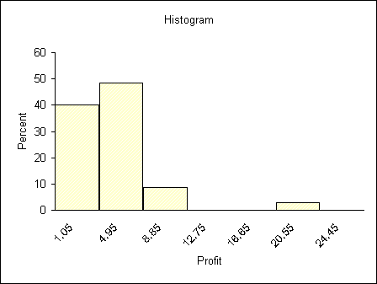
e.

4. In order to control costs, a company wishes to study the amount of money its sales force spends entertaining clients. The following is a random sample of six entertaining expenses (dinner costs for four people) from expense reports submitted by members of the sales force
$157 $132 $109 $145 $125 $139
- Show the equivalence of the following two formulas:
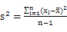 , 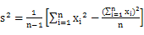.
- Calculate , 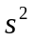, and s for the expense data, use the two different formulas in (a) to calculate.
- Assuming that the distribution of entertainment expenses is approximately normally distributed, calculate estimates of tolerance intervals containing 68.26 percent, 95.44 percent, and 99.73 percent of all entertainment expenses by the sales force.
- If a member of the sales force submits an entertaining expense (dinner cost for four) of $190, should this expense be considered unusually high (and possibly worthy of investigation by the company)? Explain your answer.
Solution:
a.
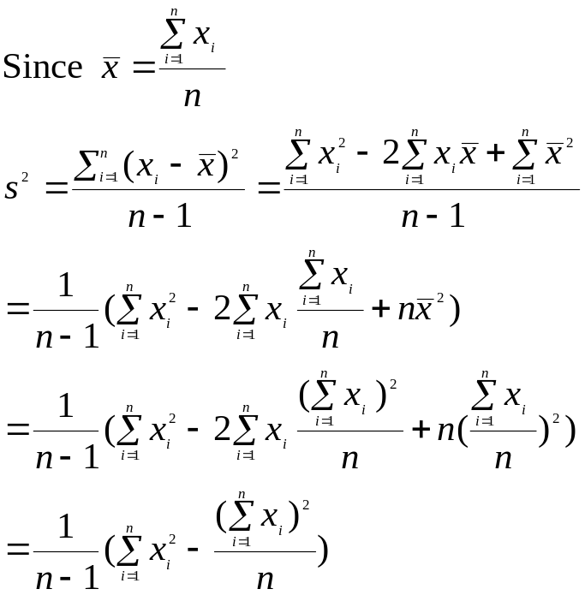

b.
= 276.7
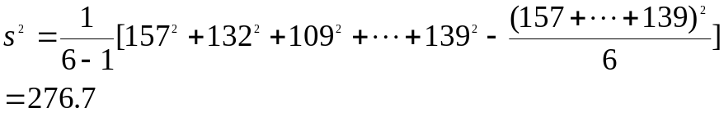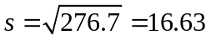
c. 68.26 percent
95.44 percent
99.73 percent
d. 190 should be considered unusually high due to 190 is beyond the tolerance intervals of 99.73%.

5. A group of 13 students is studying in Istanbul, Tukey, for five weeks. As part of their study of the local
economy, they each purchased an Oriental rug and arranged for its shipment back to the United States. The
shipping time, in days, For each rug was
31 31 42 39 42 43 34
30 28 36 37 35 40
Estimate the percentage of days that are within two standard deviations of the Mean. Is it likely to take 2
months for a delivery?
Solution:
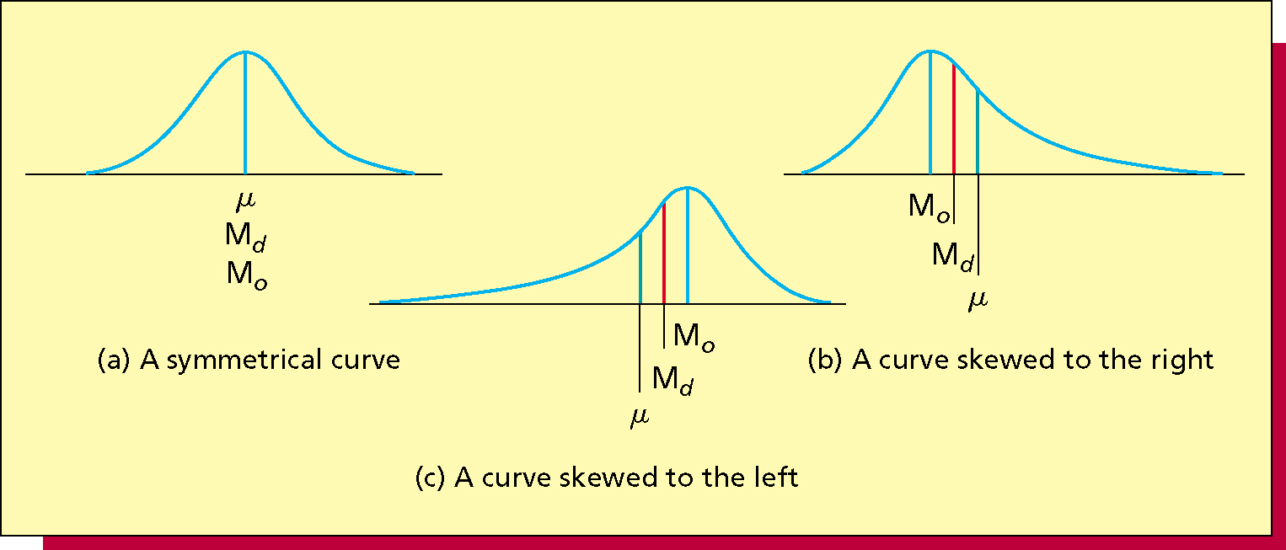
a. Because of the mean equals to the median 36,so we assume it normal curve.
b. The mean equals to 36, Standard Deviation equals to 5, three standard deviations
of the Mean is the interval [36-3*5,36+3*5]=[21,51], 99.73% will go to this
interval. So 2 months(60) seldom for a delivery.

Table for question 3:
The Forbes platinum list: Best-performing retailers as listed at Forbes.com on March 16, 2005
Company | Profit | Return on Capital (%)
 | Margin (%) | Last 12 Months
Abercrombie & Fitch | 10.9 | 25.7
Advance Auto Parts | 5.0 | 17.0
Amer Eagle Outfitters | 6.1 | 14.7
AnnTaylor Stores | 5.9 | 11.6
Bed Bath & Beyond | 9.2 | 22.8
Best Buy | 3.3 | 21.7
CDW | 4.0 | 20.6
Charming Shoppes | 3.1 | 8.3
Claire's Stores | 11.2 | 20.3
Costco Wholesale | 1.8 | 0.0
CVS | 3.2 | 11.2
Dollar General | 4.4 | 18.3
Ebay | 24.0 | 13.1
Electronics Boutique | 2.9 | 19.2
Family Dollar Stores | 5.0 | 19.7
Foot Locker | 5.3 | 12.8
Fred's | 2.2 | 9.2
Guitar Center | 3.9 | 15.9
Home Depot | 6.9 | 19.8
Kohl's | 5.9 | 11.5
Lowe's Cos | 5.9 | 14.7
Michaels Stores | 5.9 | 14.4
Neiman Marcus Group | 5.8 | 12.7
O'Reilly Automotive | 7.0 | 12.6
Pacific Sunwear | 8.6 | 25.1
Petsmart | 5.0 | 15.4
Regis | 5.4 | 11.0
SCP Pool | 5.2 | 20.8
Staples | 4.7 | 15.2
Target | 6.8 | 8.6
TJX Cos | 4.9 | 33.4
Tractor Supply | 3.6 | 16.5
United Auto Group | 1.1 | 4.0
Walgreen | 3.6 | 17.6
Williams-Sonoma | 5.9 | 21.1

